Applying to Job Posting – Internal Candidate Quick Reference Guide
Last Updated: 01/09/2018
Jump Links: Access SuccessFactors, Candidate Profile, Search Jobs, Submit Application (from Job Search), Submit Application (from Email Notification), Monitor Application Status, Respond to Offer, Create Job Alert
This Quick Reference Guide outlines the steps for current employees to create a candidate profile and apply to a job posting.

Access SuccessFactors
Visit OneCampus and select Employee Launchpad.  Log in using Purdue Career Account ID and password. | https://one.purdue.edu/

Candidate Profile
Candidates must create a profile prior to applying for a job.
From the Success Factors home page, click the Home drop-down menu and select Careers. | 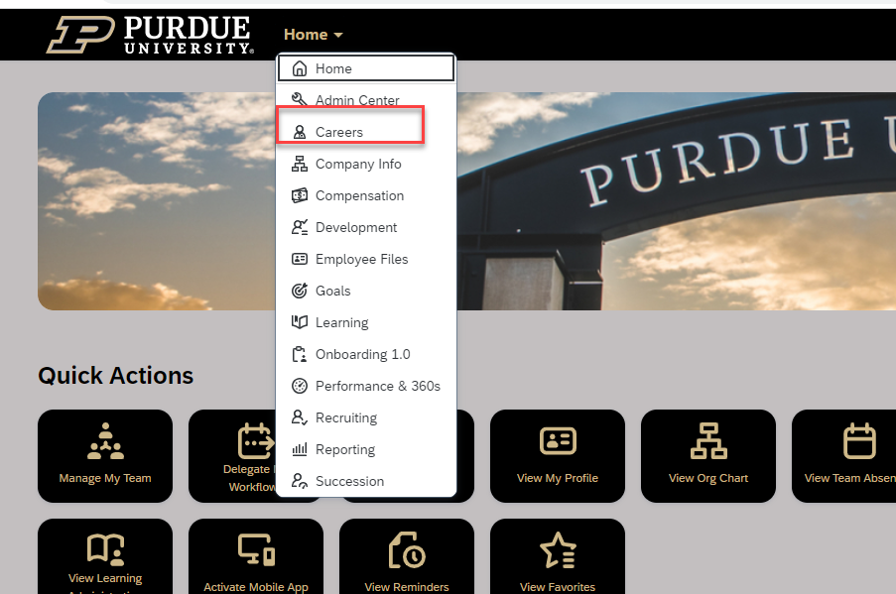
Click My Candidate Profile. | 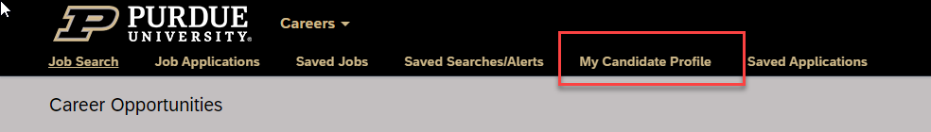
Click Browse… to select resume file.  NOTE: File type must be DOCX, PDF, Image or Text.  Click Upload. | 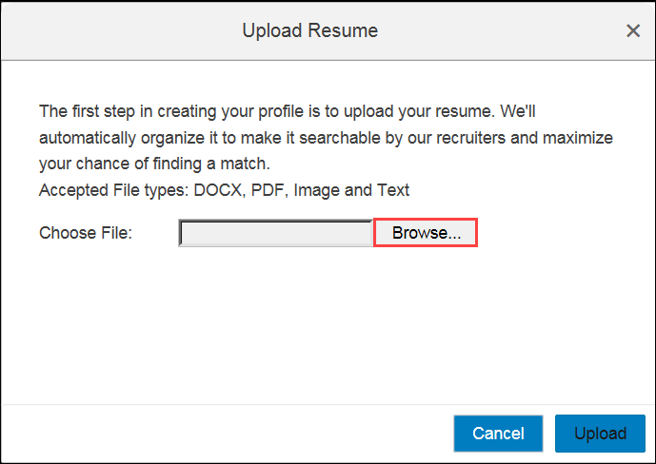
As the file uploads, the system automatically attempts to organize the information into the appropriate categories and fields. | 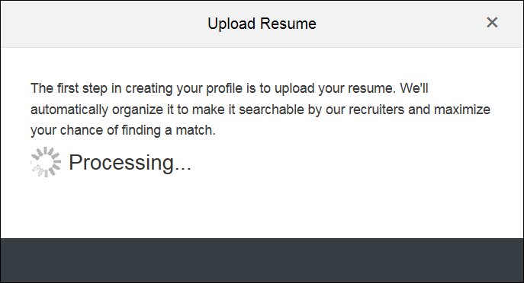
Successful upload of the resume file is displayed.
To upload a cover letter or a new resume, click appropriate link.
Complete any missing required information such as phone and address. | 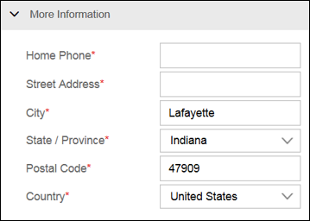
Auto-loaded information from the resume file will populate some of the previous employment, education, languages, and certifications sections. Make any necessary corrections to the parsed information.  NOTE: If a resume has been uploaded it is not necessary to complete the information section.  If not uploading a resume/CV, the information in this section should be completed in as much detail as possible. | 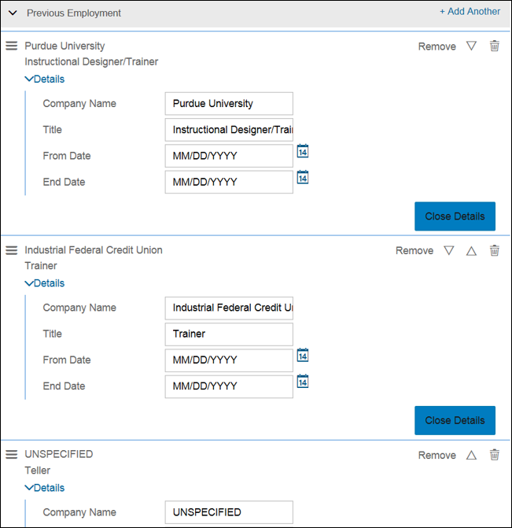
Click Save before leaving profile. | 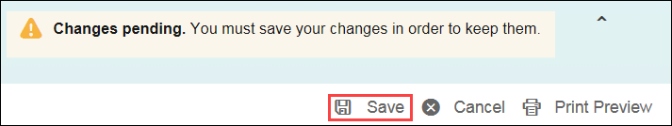

Search Jobs
From the Success Factors home page, click the Home drop-down menu and select Careers.
Click Job Search. | 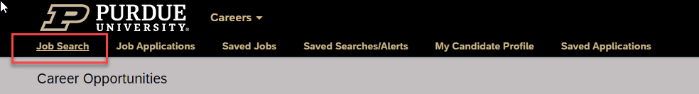
To narrow search, select specific criteria from available fields.  To run the search wide open, leave fields blank.  Click Search Jobs. | 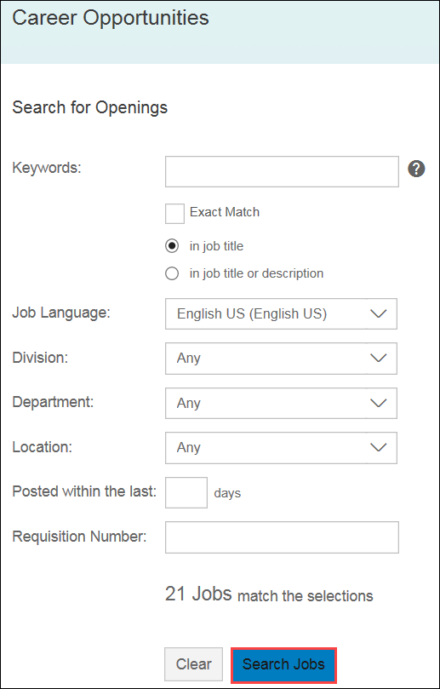
A list of internally posted positions is displayed.  To narrow results, the same search criteria is located on the left side of the results screen.  NOTE: All external postings will be listed on the internal SuccessFactors site, for Purdue Employees to consider. | 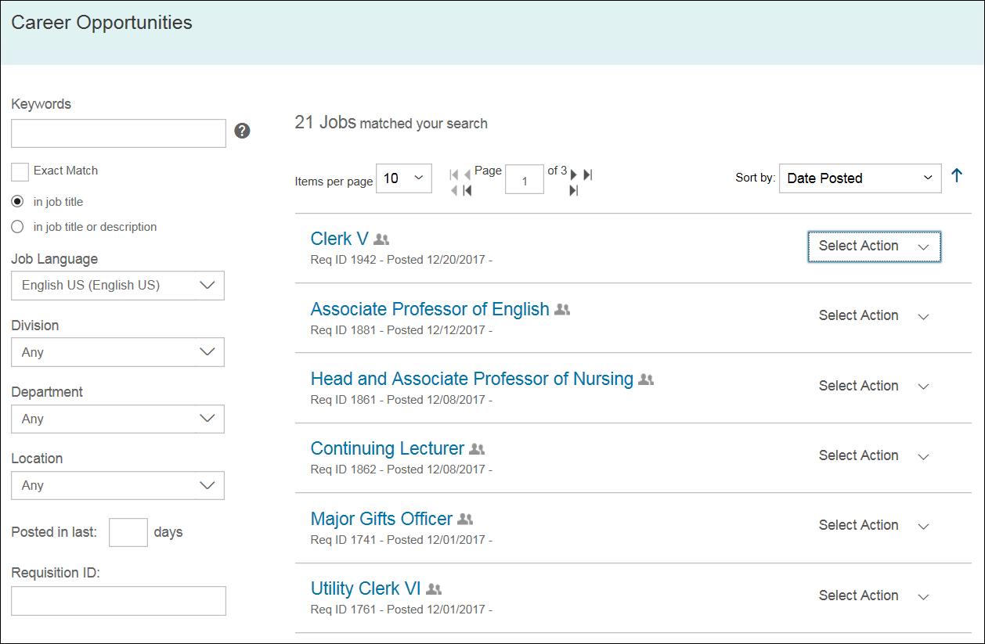

Submit Application (from Job Search)
To apply for a posted position, click the corresponding Select Action drop-down menu and select Apply. | 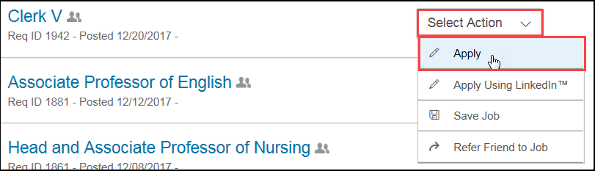
Review candidate profile and make changes as needed.  Click Next. | 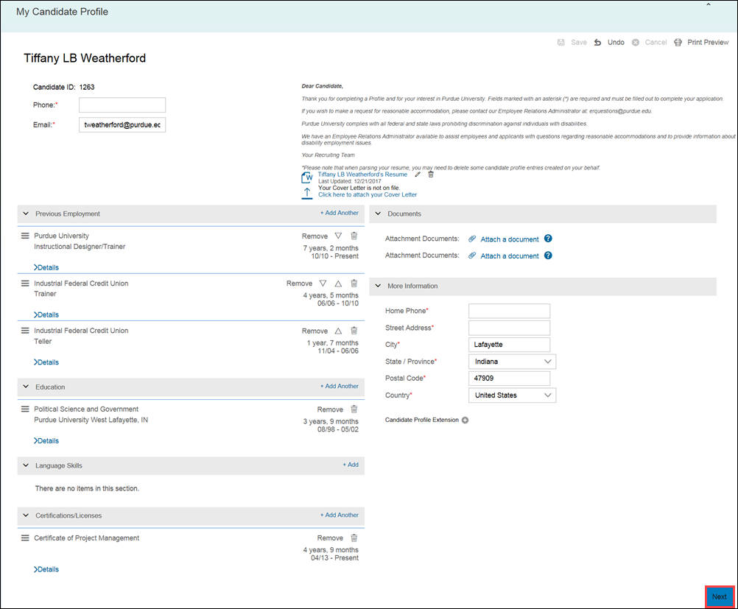
Complete all required information and answer citizenship, race, diversity, disability, veteran status, and employment questions. | For example:  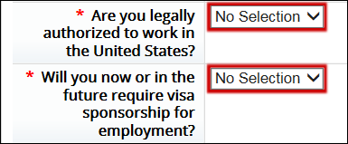
Enter Name and Date to electronically sign application. | 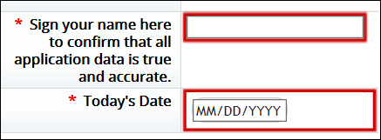
To save application without submitting, click Save.
A notification displays that the application was saved successfully. | 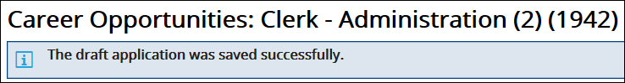
To submit application, click Apply.
A notification displays that the application was successfully submitted. | 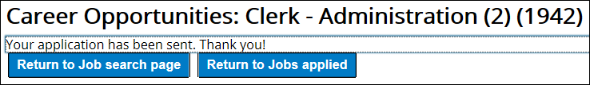

Submit Application (from Email Notification)
Click the Apply to this job now… link in the notification email to view job posting and apply. | 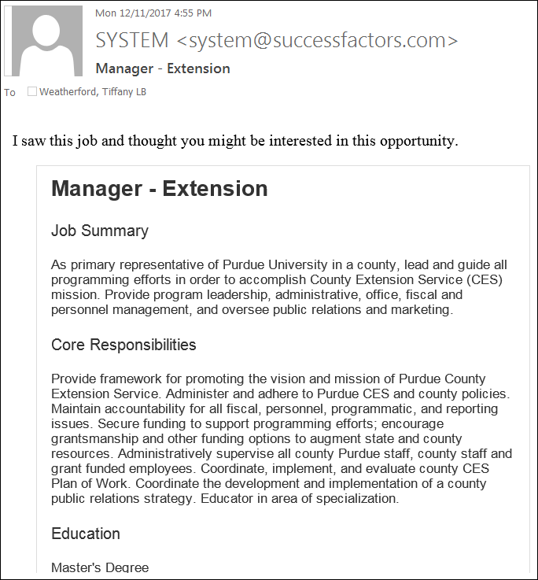
Log in to SuccessFactors.
The Job Listing is displayed.  To submit application, click Apply. | 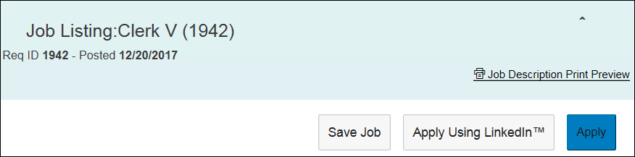

Monitor Application Status
From the Success Factors home page, click the Home drop-down menu and select Careers.
Click Job Applications. | 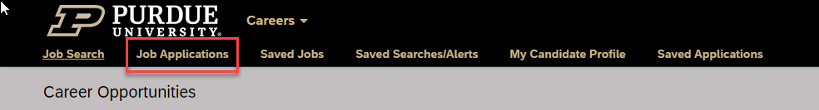
All jobs to which you applied that are still open are displayed.  The Status of the application is also displayed. | 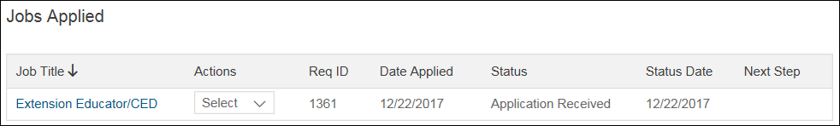

Respond to Offer
From the Success Factors home page, click the Home drop-down menu and select Careers. | 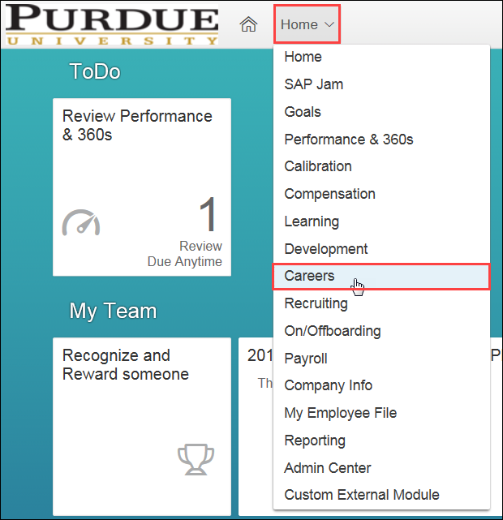
Click My Offers.
Read and review Offer Letter. | 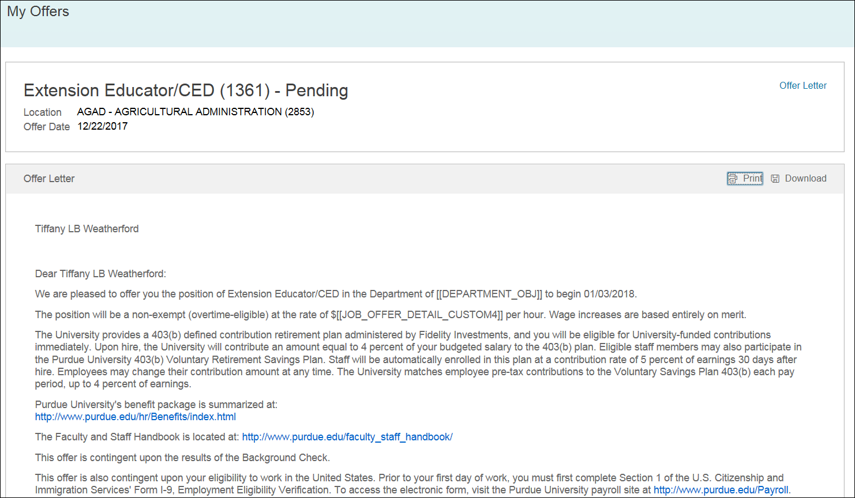
To accept, click Accept Offer.  To correspond regarding the offer prior to accepting, click Email Recruiter.  To decline, click Decline Offer. | 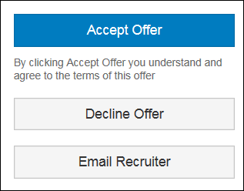

Create Job Alert
From the Success Factors home page, click the Home drop-down menu and select Careers.
Click Saved Searches/Alerts.
Click Create New Job Alert. | 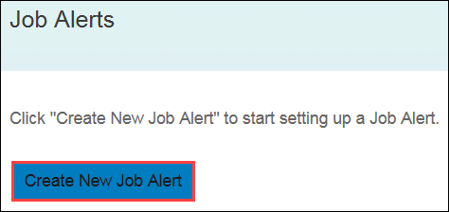
Create Name of search and Email frequency.  Select specific criteria from available fields.  When finished, click Save. | 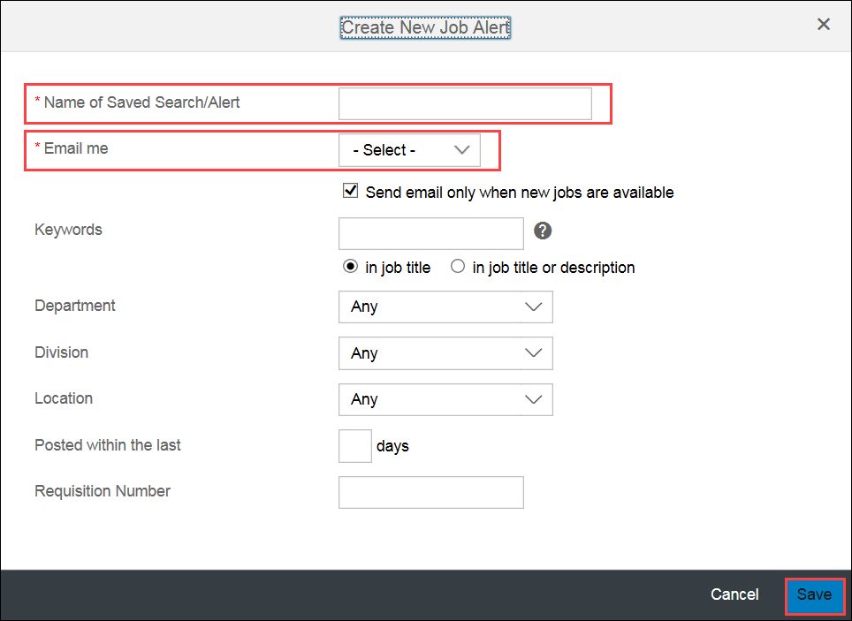
The search is now saved and email notifications will be sent according to the Alert Schedule selected.

